JANALAKSHMI FINANCIAL SERVICES
CBS DB FLASH COPY SCRIPT EXECUTION PROCEDURE – SOP

OBJECTIVE: EXEUTING FLASH COPY THROUG SHELL SCRIPT

Step1: Login to Flashcopy DB Server 172.17.70.237 with oracle user

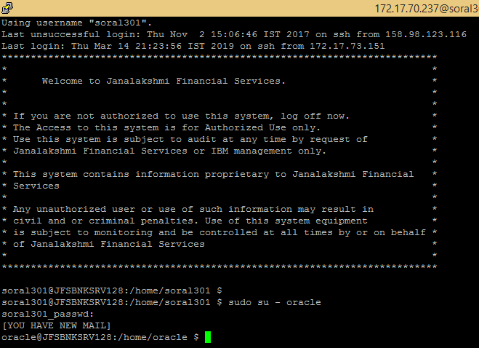

Step2: Shutdown all the databases using below script

cd /osbackup/oracle_backup/BCV_SCRIPTS

sh db_down.sh

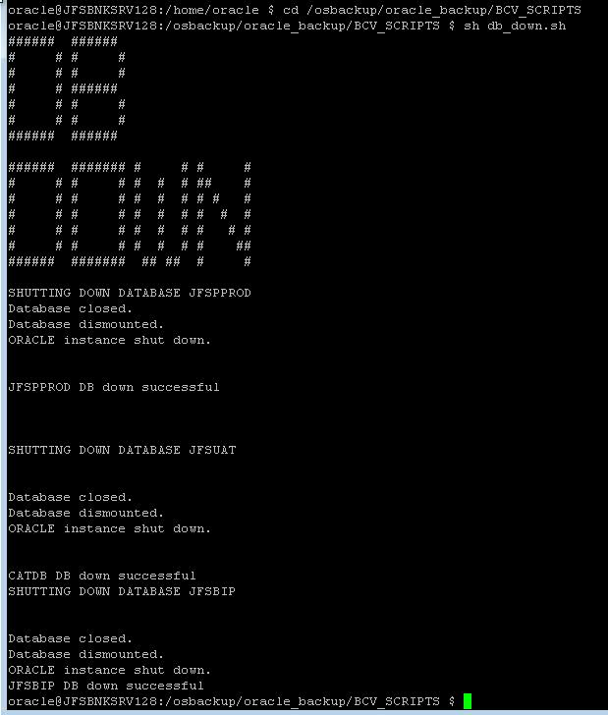

Exit from Oracle user

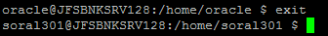

Step 3: Shutdown ASM using Grid ID

su – grid (Switch to grid user)

sh ASM_down.sh

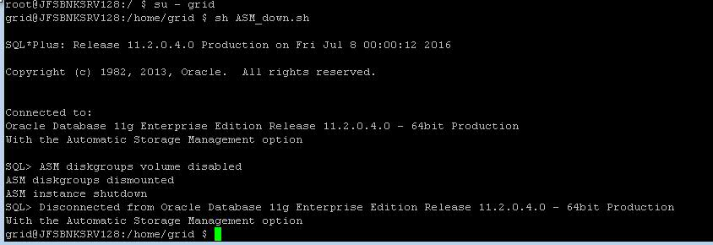

Exit from grid user



Step 4: Begin the Backup mode in PROD DB Server 172.17.70.230 server using Oracle ID

cd /fcarch/BCV-SCRIPTS

sh Begin-Backup.sh

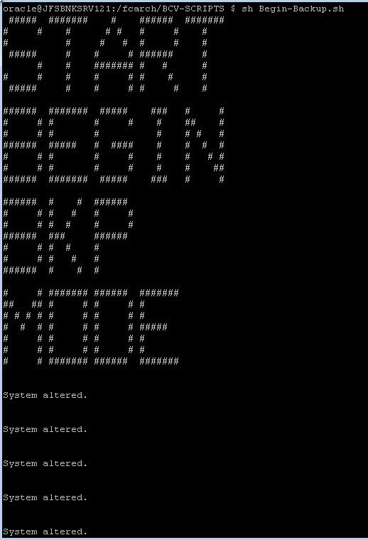

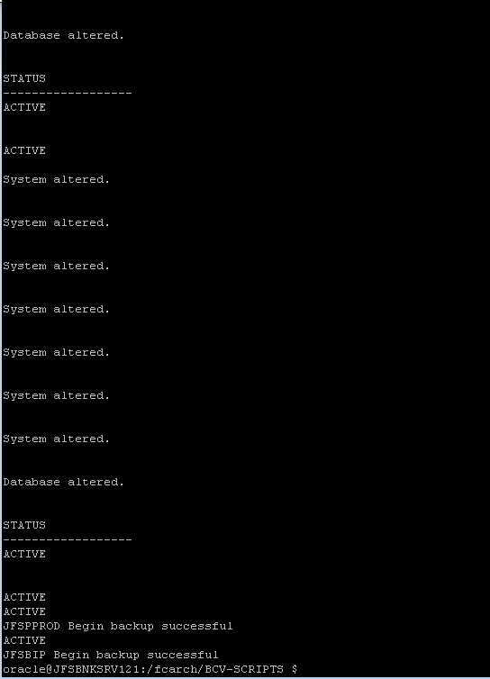

Step 5: Flash Copy Execution from 172.17.70.237 server using FCRPRO ID

cd /home/FCRPROD/storage/Live

sh run_flash_jfsbank.sh

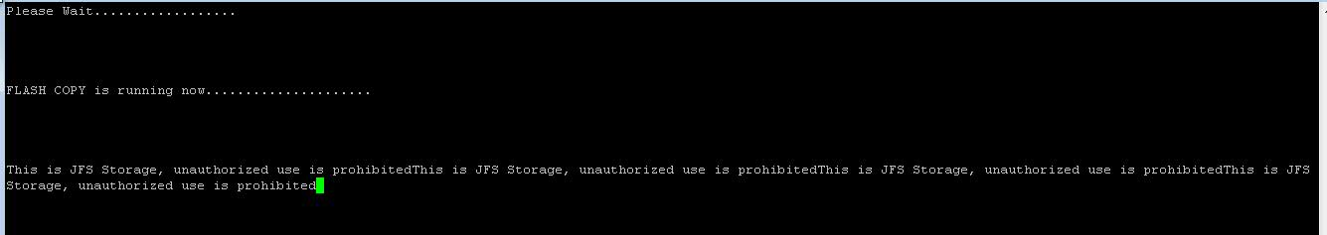

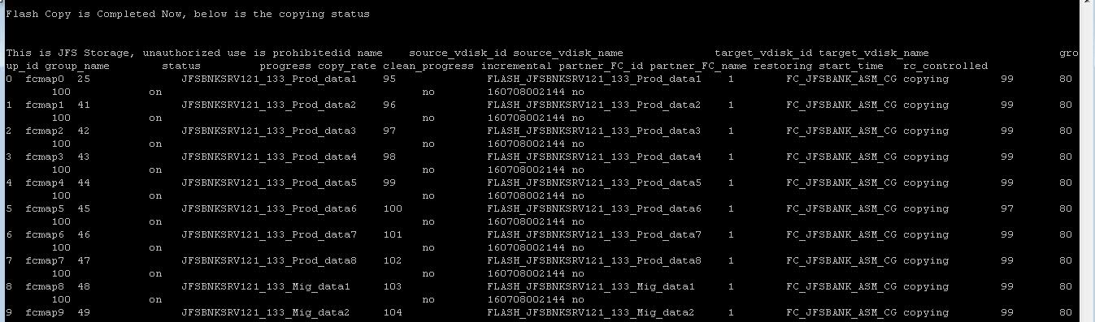

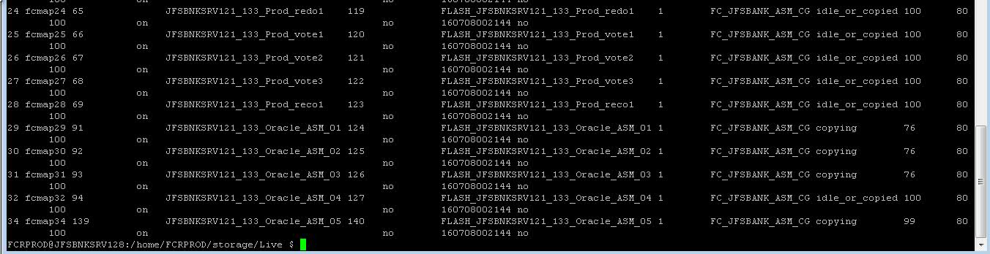

Step 6: End the Backup mode in PROD DB Server 172.17.70.230 server using Oracle ID

cd /fcarch/BCV-SCRIPTS

sh END-Backup.sh

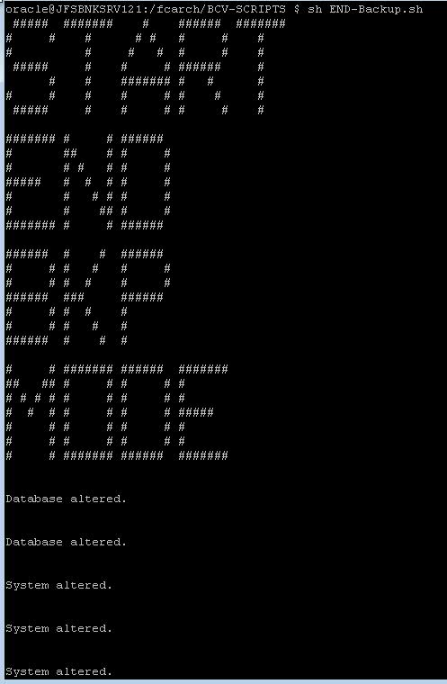

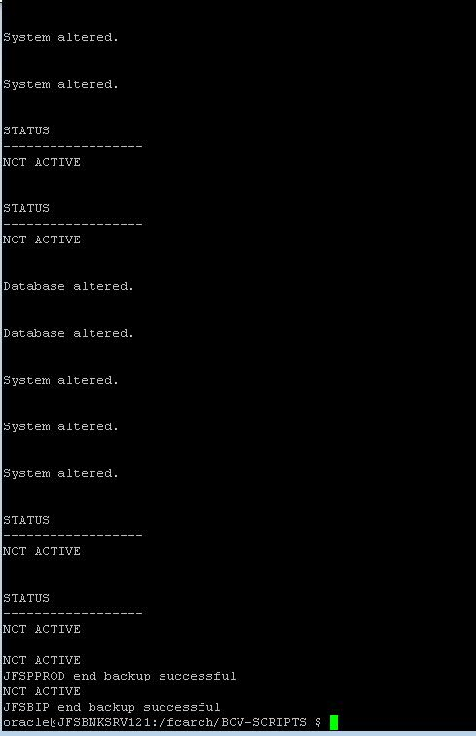

POST Step-6 PROD Database can be used for EOM / BOM Activities
Step 7: Copy the latest Archive files & Controller file from PROD DB Server 172.17.70.230 to Flashcopy DB Server 172.17.70.237 using Oracle ID

cd /fcarch/BCV-SCRIPTS

sh Arch-cp.sh

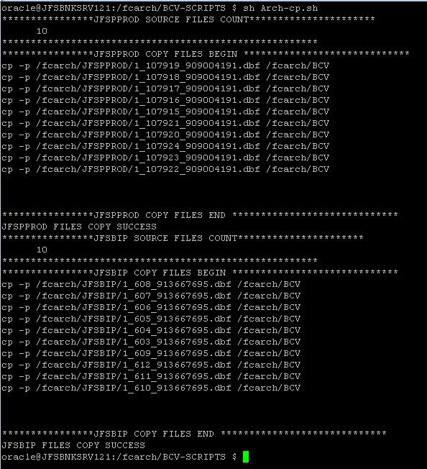

sh SCP-Rmt.sh

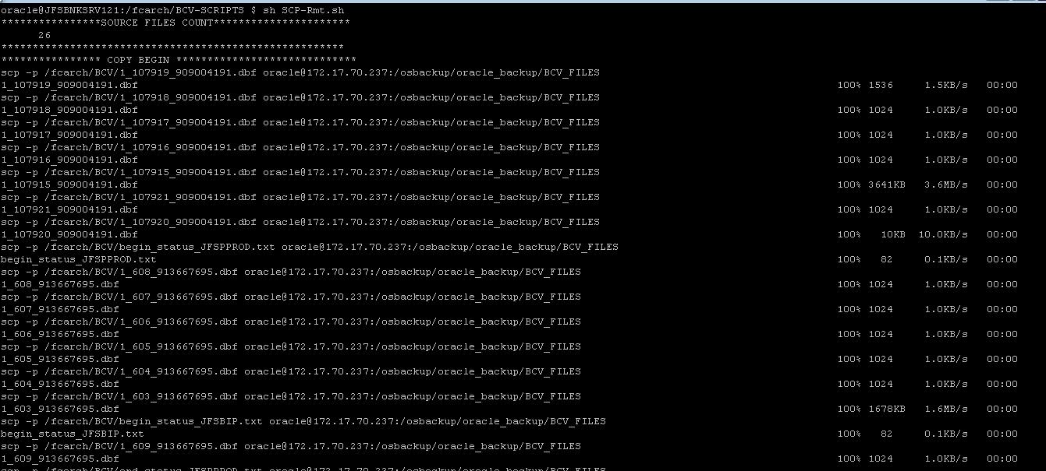

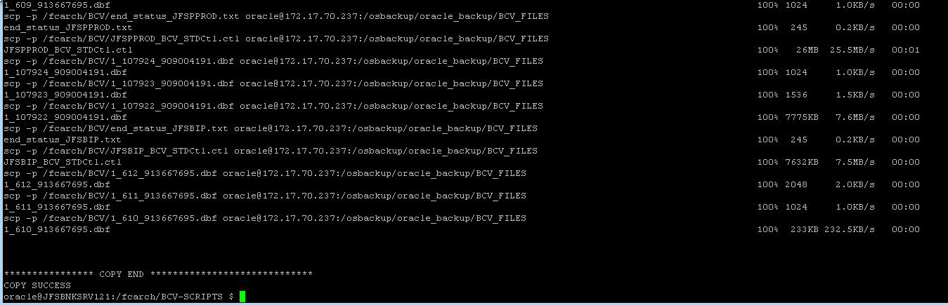

Step 8: Start ASM in Flashcopy DB server 172.17.70.237 server using grid ID

sh ASM_start.sh

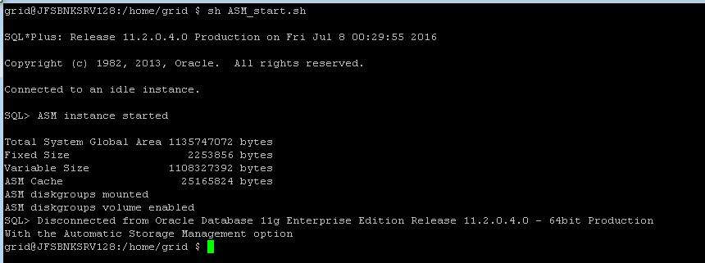

Exit from grid user

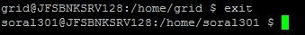

Step 9: Start Catalog Database in 172.17.70.237 server using Oracle ID

su – oracle (Switch to Oracle user)

cd /osbackup/oracle_backup/BCV_SCRIPTS

sh CATDB_start.sh

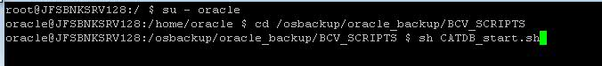

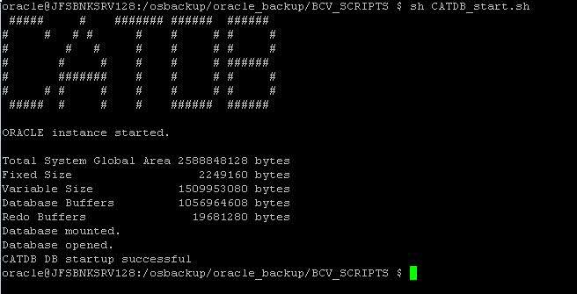

Step 10: Start Flash DB in No-mount in 172.17.70.237 server using Oracle ID

sh BCV-STR-NOMOUNT.sh

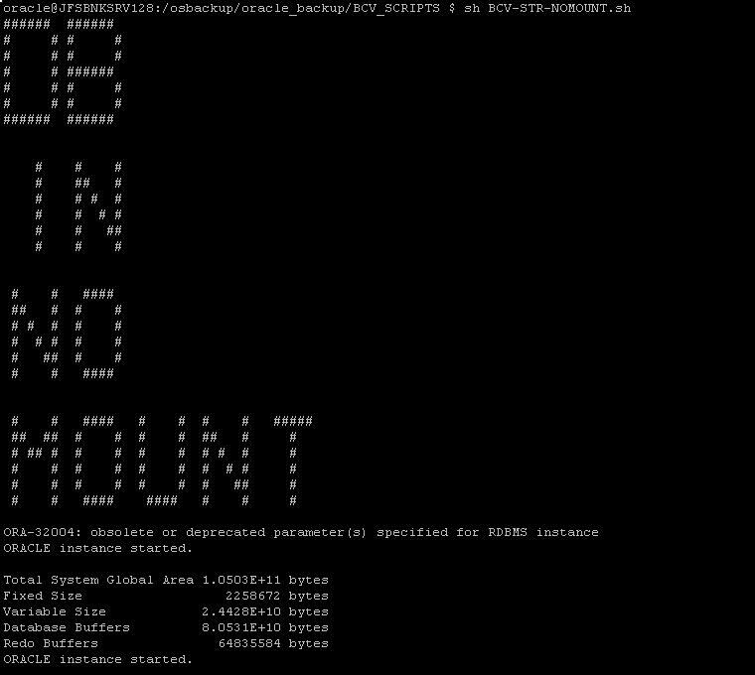

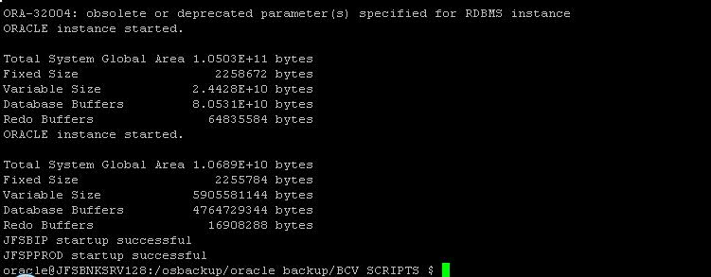

Step 11: Start Flash DB in Recovery in 172.17.70.237 server using Oracle ID

sh JFSPPROD_BCV_Mas.sh

Note: This step will take approx. 5mins to complete

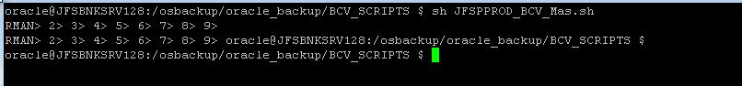

Step 12: Start Flash DB in Read Only mode in 172.17.70.237 server using Oracle ID

Note: This step will take approx. 5mins to complete

sh BCV-RO-DB.sh

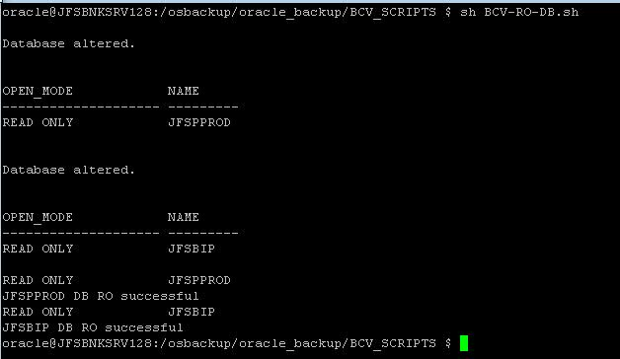

----- End of Document -----

